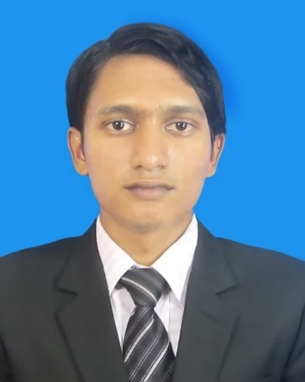

Md. Sifat Hossain  
Phone Number: 01962471233,01728651548  
Email Address: [sifat1258@gmail.com](mailto:sifat1258@gmail.com)

Career ObjectiveA dedicated and energetic individual seeking to as a software engineer to contribute to the delivery of quality software solutions by applying interpersonal skills and knowledge of program design.

**Education**

**Graduation**

Institution: International University of Business, Agriculture and Technology

Passing year: Studying

Subject: Bachelor of Computer Science and Engineering (BCSE)

# Higher Secondary Certificate Examination

Institution: Vasha Shaheed Abdul Jabber Ansar V.D.P School & College

Passing Year: 2012

Group: Science

Result: 4.75

Board: Dhaka

# Secondary School Certificate Examination

Institution: Ranashal High School

Passing Year: 2010

Group: Science

Result: 5.00

Board: Dhaka

**Training Details**

**LICT FOUNDATION SKILLS IT TRAINING FOR .NET**

**Duration: 300 Hours**

**Technical skills**

* Having good knowledge of .Net(windows form), ASP.Net, PHP,CSS, MySQL
* Knowledge of MS Word, MS Excel, Ms power point, Internet Browsing

**Personal Project**

* ATM Card History Management
  + - Java Based Software Development
* Automated CV Sorting
  + - .Net Based Software Developed
    - Done The Interface Designing and Logical Implementation
* IUBAT Bus Booking Management System)
  + - Done Analysis Based Idea development
    - Came up with Innovative ideas for Software Development
    - .Net Based Software Project

**Language Proficiency**

|  |  |  |  |
| --- | --- | --- | --- |
| **Language** | **Reading** | **Writing** | **Speaking** |
| Bengali | Excellent | Excellent | Fluently |
| English | excellent | good | Fluently |

**Personal Details**

Name: Md. Sifat Hossain

Date of Birth: 30th January, 1997

Father’s Name: Md Shahinur Rahman

Mother’s Name: Khurshed Jahan

Present Address: House No. 65, Road No. 12, Sector 10, Uttara, Dhaka-1230

Permanent Address: village: Ranashal, P/S: Mirzapur, District: Tangail.

Nationality: Bangladeshi

Religion: Islam

Blood Group: B+

Height: 5’5’’

**References**

Pr. DR. Utpal Kanti Das

Coordinator and Faculty

Department of Computer Science and Engineering, IUBAT

Cell: 01819199419

E-mail: ukd@iubat.edu

Md. Asaduzzaman Arif

Project Manager & Principal Trainer

Master Trainer @LICT Project

Cell: 01841111102

E-mail: asad.ist@gmail.com